Whole Wheat Protein Pancakes

* [New](http://www.teambeachbody.com/teambeachbodyblog/category/new)

* [Nutrition](http://www.teambeachbody.com/teambeachbodyblog/category/nutrition)

* [Recipes](http://www.teambeachbody.com/teambeachbodyblog/category/nutrition/recipes)

2 days ago



These yummy whole wheat pancakes made with cottage cheese are packed with protein. A satisfying way to start your day!

**Total Time:** 19 min.  
**Prep Time:** 10 min.  
**Cooking Time:** 9 min.  
**Yield:** 6 servings, 1 pancake each

**Ingredients:**  
1 cup nonfat cottage cheese  
6 large eggs  
½ cup whole wheat flour (or ¼ cup whole-wheat and ¼ cup barley flour)  
1 Tbsp. coconut oil, melted  
1 pinch sea salt  
1 tsp. pure vanilla extract  
¼ cup nonfat milk  
Nonstick cooking spray

**Preparation:**  
1. Place cottage cheese, eggs, flour, oil, salt, and extract in a blender or food processer; cover. Blend until smooth.  
2. Add milk slowly to reach batter consistency.  
3. Heat a large nonstick skillet lightly coated with spray over medium-high heat. Ladle ¼ cup batter for each pancake; cook for 2 to 3 minutes, or until bubbles cover the top. Flip; cook for an additional minute, or until golden brown. Repeat with remaining batter.

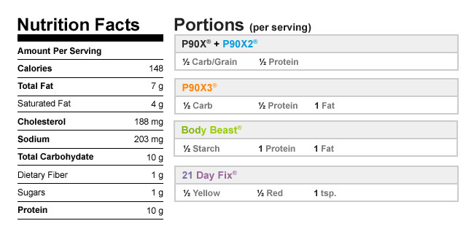

Authors

[Beachbody](http://www.teambeachbody.com/teambeachbodyblog/author/beachbody)

Tags[breakfasts](http://www.teambeachbody.com/teambeachbodyblog/tag/breakfasts), [high-protein recipes](http://www.teambeachbody.com/teambeachbodyblog/tag/high-protein-recipes), [recipes](http://www.teambeachbody.com/teambeachbodyblog/tag/recipe),[vegetarian](http://www.teambeachbody.com/teambeachbodyblog/tag/vegetarian)

RELATED POSTS